RELATIONSHIPS and SEXUALITY EDUCATION IN PRIMARY SCHOOLS

Parent Information Leaflet
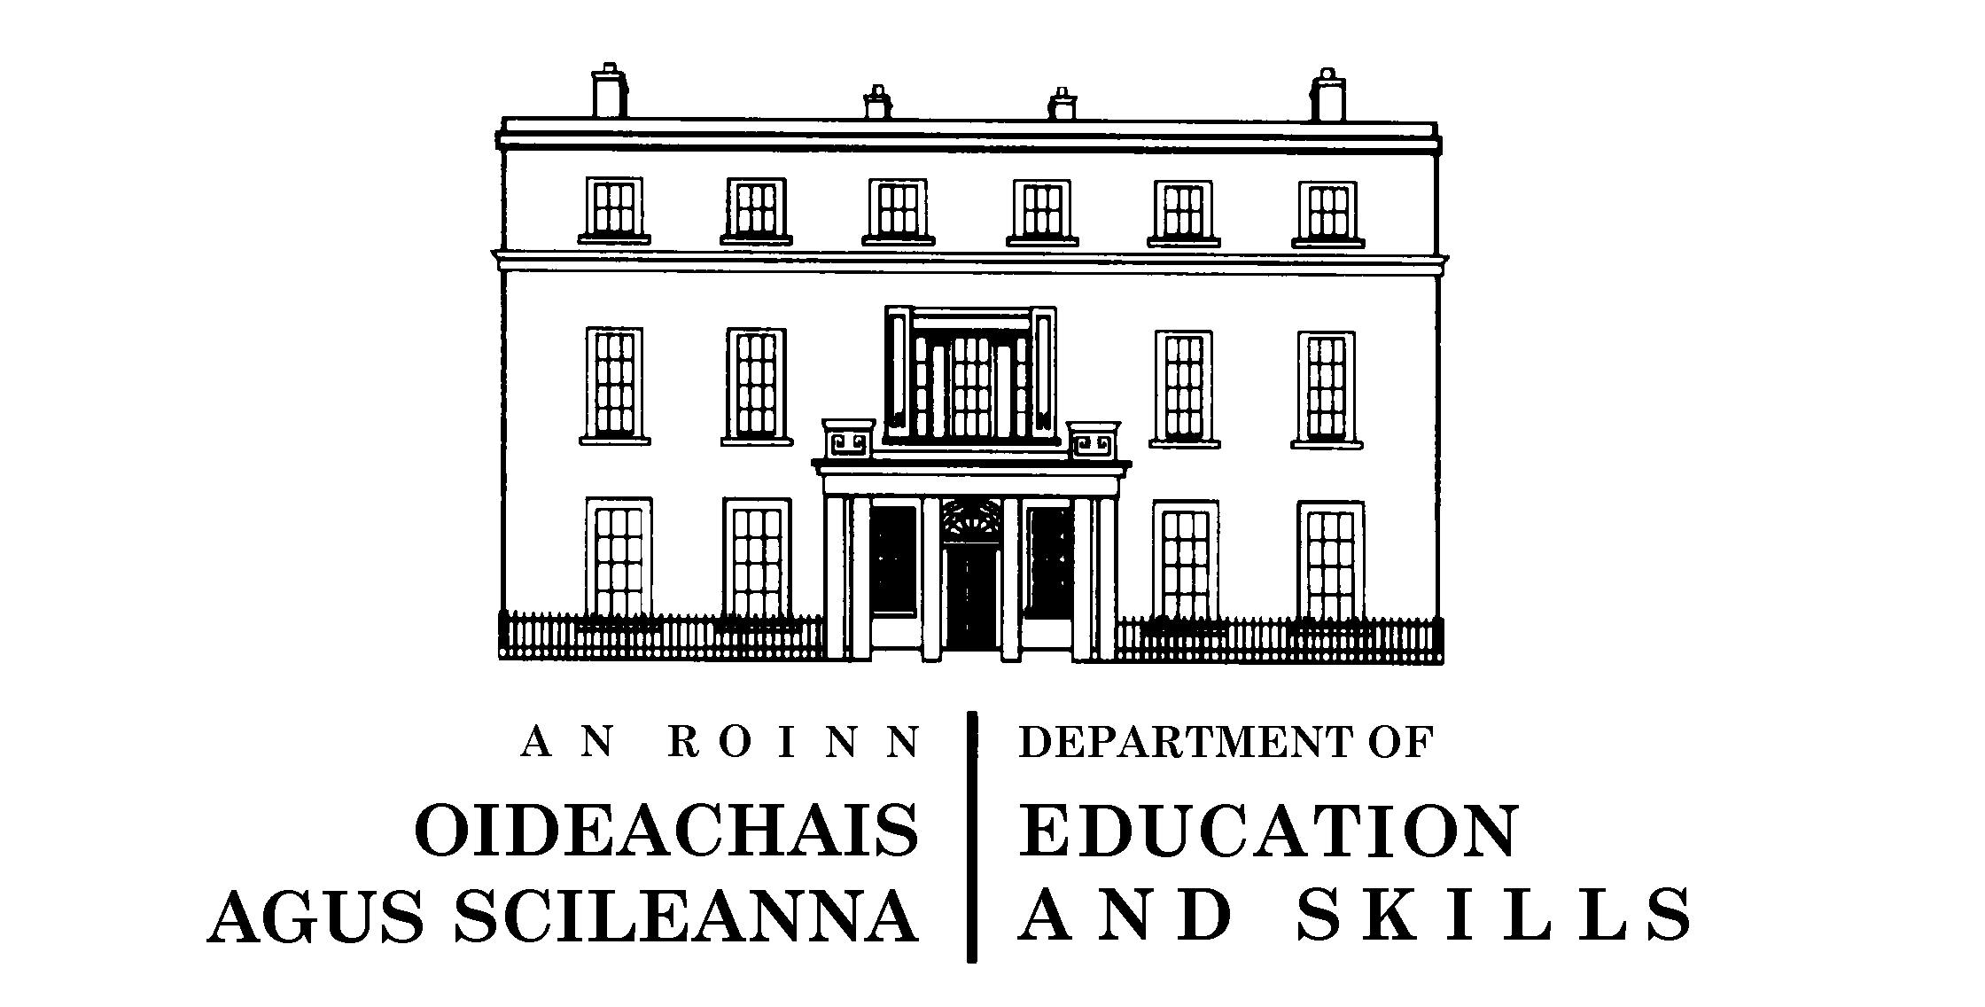

Introduction

Learning about relationships and sexuality is a process that goes on throughout our lives. Children learn primarily from their families. Therefore, as a parent, you are the first and most important teacher of your child when it comes to relationships and sexuality. A school based Relationships and Sexuality Education (RSE) programme can complement and support what children are learning at home. RSE is most effective when schools and parents work in partnership.

Partnership is supported when schools:
- Inform parents about what will be taught in RSE, and when it will be taught
- Consult with parents of a child with a learning difficulty to ensure that his/her needs are being met.
- Collaborate with parents when reviewing their RSE policy

The Department of Education and Skills requires all schools to teach RSE and to have an RSE policy. The policy will ensure that RSE is taught in a way that reflects the core values and ethos of the school.

The purpose of this leaflet is to give you some information about RSE. For more detailed information please go to the Drumcondra Education Centre website: www.ecdrumcondra.ie/programmes/rse

What is RSE?

RSE teaches children about relationships, sexuality and their own growth and development. The lessons give children the opportunity to reflect on their lives and their relationships in a social, moral and spiritual framework. RSE is taught in the context of a wider subject called Social Personal and Health Education (SPHE).

SPHE provides opportunities to:
- Foster the personal development of children
- Promote the health and well being of children
- Help children to maintain supportive relationships
- Encourage children to become active, responsible citizens

The lessons in SPHE are arranged under three strands: Myself, Myself and Others, Myself and the Wider World.

The RSE programme is incorporated into the strands Myself and Myself and Others. Each strand is sub-divided into strand units. These are shown below, with a very brief summary of their content.

The Stay Safe Programme is also an aspect of SPHE and should be taught under the strand unit ‘Personal Safety’. The programme helps children to deal with upsetting, unsafe or frightening situations. For more information go to: www.staysafe.ie

JUNIOR INFANTS TO SECOND CLASS

MYSELF:
Self Identity: What makes me unique and special, becoming self reliant, making choices, expressing opinions.

Taking Care of My Body: Caring for one’s body, respect for one’s body and that of others, diet, hygiene, being able to name parts of male and female body using appropriate anatomical terms.

Growing and Changing: Understanding growth and change, exploring feelings, becoming aware of new life and birth, understanding a baby’s needs.

Safety and Protection: Identifying risks, developing strategies for keeping safe, understanding why there are rules.

MYSELF AND OTHERS:
Myself and My Family: Learning about how families love and take care of each other.

My Friends and Other People: Appreciating friendship, treating others with dignity and respect, recognising bullying behaviour, understanding that it is wrong and knowing what to do about it.

Relating to Others: Listening to others, practicing care and consideration towards others, resolving conflict.

MYSELF
Self Identity: Self awareness, self confidence, expressing feelings and opinions, coping with change, becoming more responsible, body image, identifying goals and targets.

Taking Care of My Body: Understanding health, dangers of substance misuse, personal hygiene, nutrition. For 3rd/4th Class: understanding physical changes for boys and girls. For 5th/6th Class children: understanding physical and other changes at puberty, understanding the male and female reproductive system.

Growing and Changing: Identifying and discussing feelings, having a positive sense of self. For 3rd/4th Class children: being able to discuss the development of the human baby from conception to birth, recognising how feelings are influenced by puberty. For 5th/6th Class children: understanding sexual intercourse, conception and birth in the context of a committed, loving relationship.

Safety and Protection: Identifying threats to safety, knowing how to keep safe, helping others to be safe.

Making Decisions: Decision making, understanding that decisions have consequences, recognising the role of adults in setting boundaries for young people.

MYSELF AND OTHERS
Myself and My Family: Exploring what it means to belong to a family, identifying behaviour that promotes harmony in families.

My Friends and Other People: Appreciating the importance of friendship, coping with the loss of friendship, learning how to deal with bullying, recognising the importance of courtesy, good manners and caring for others.

Relating to Others: Listening and communication skills, positive strategies for resolving conflict.
THIRD CLASS TO SIXTH CLASS

