What do you want to find out?
Which paper absorbs the most water
What will you change?
We will change the paper brand.
What will we keep the same?
We will keep the measurement of water and the size of paper the same.
How will we test what paper absorbs the best?
We will measure the amount of water left in the glass after we put the kitchen paper in.
WHAT YOU WILL NEED
3 Different brands of paper
3 Cups
A measuring jug
Water
{Towels it can get wet}
METHOD
- First label all of the cups then make all the kitchen sheets the same size by measuring them carefully and cutting them.
- Next get three cups (all the same) and fill each cup with 150ml of water
- Set a timer for 1 minute
- Then at the same time drop the three sheets of paper in
- Leave them for 1 minute and take them all out at the same time
- Set them aside
- Now measure the amount of water left in each cup{the cup that has the least amount of water left is the one that absorbed the most}
RESULTS
Regina absorbed the most water!

BRAND | SOAKED UP | AMOUNT LEFT
REGINA | 45ML | 105ML
NICKY | 25ML | 125ML
PLENTY | 38ML | 112ML

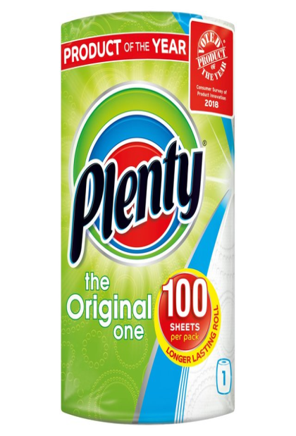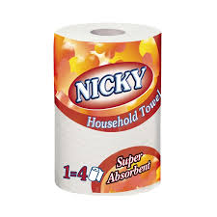
DEARG

