- What do we want to find out?
Which paper will absorb the best.
- What will we change?
The brand of kitchen paper.
- How will we test which paper absorbs the best?
We will put the same amount of water in 3 bowls and drop the same size paper into the water at the same time.
Prediction :Regina will absorb the most .
MATERIALS:
- 3 of the same size bowls
- Measuring jug
- Water (100 ml per bowl)
- Kitchen paper (3 brands)
- Timer

METHOD :
- Pour 100ml of water in to every bowl .
- Cut all pieces of kitchen paper to the same size .
- Put the kitchen paper in and start the timer (1 minute)
- Take out the kitchen paper and measure the amount of water left in each bowl.
Results:
Regina absorbed the most water!
BRAND | ABSORB | LEFT
NICKY | 7ML | 93ML
REGINA | 25ML | 75ML
PLENTY | 5ML | 95ML

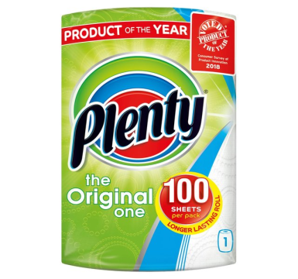 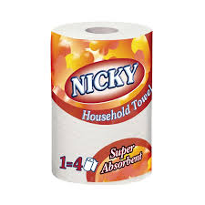 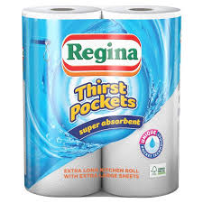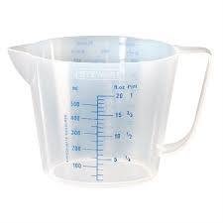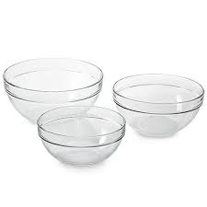 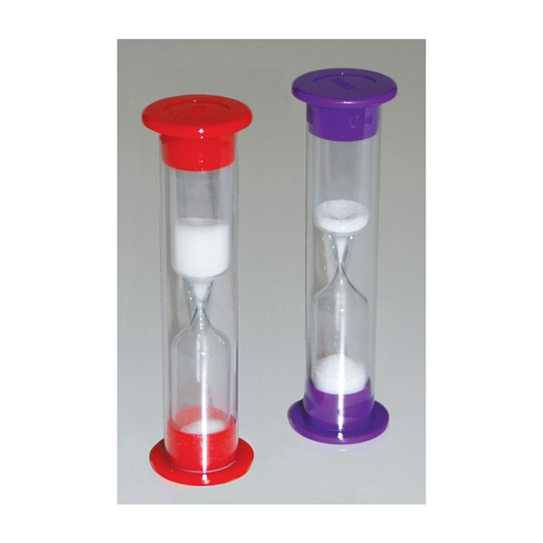TEAM: GLAS .

