What you need:
3 different types of Kitchen paper
Water
Food colouring
Ruler
Blue tack
2 even sized bottles.
3 small jars.
Scissors.
A4 paper
Timer.
Which paper absorbs the best? What will we change?
We will change the brand of paper. What will we keep the same? We will keep the amount of water and size of paper the same.

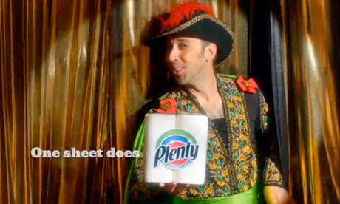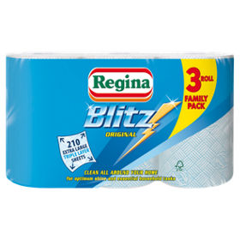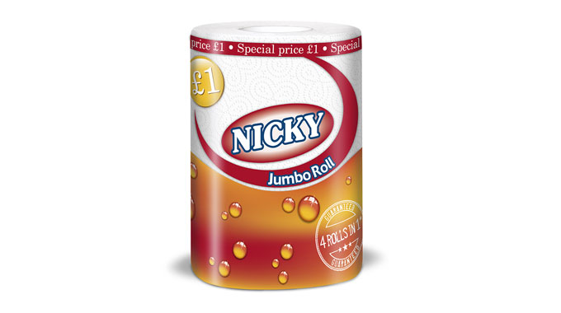
How will we test which paper absorbs the best
We will test which paper absorbs the most water by putting the same amount of water into each jar (100 ml). We will put the strips of paper into the water at the same time and make sure that all sheets of paper are all the same size.
METHOD:
First: get the bottles and stick blue tack on the top of the bottle.
Second: get the ruler and stick it on to the top of the bottle.
Third: cut the three different types of kitchen paper evenly in strips.
Fourth: fill the jars with water 100ml of water and put a few drops of food colouring in the water.
Fifth: Stick the kitchen paper on to the ruler with blue tack, and then set the timer for one minute.
Sixth: Turn on the timer and put the kitchen paper into the jar. Take out after 1 minute.
Seventh: Measure the distance the water has travelled on the paper to see which one absorbed the best.
Results:
Nicky = 15cm
Regina= 9.3cm
Plenty= 6.2cm
Nicky was the most absorbent kitchen paper

